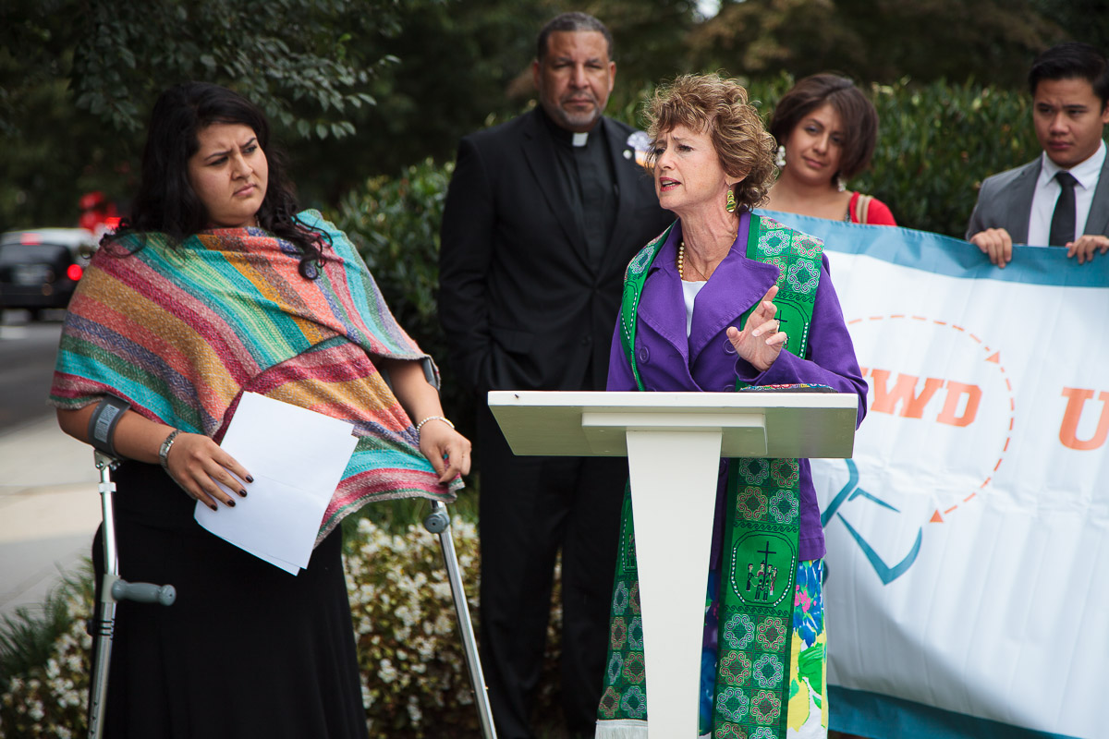

TOOLKIT ON ORGANIZING FOR JUST IMMIGRATION POLICIES AT THE LOCAL AND STATE LEVEL
A Resource for Local Action
Over the next two years, immigration policy will not be made at the federal level because of gridlock between congressional chambers and the executive branch. This means that immigration policy will be forged primarily at the state, county and city level. The below toolkit is designed to strengthen your organizing efforts on key immigration policy issues that will likely be moving in a local space near you.
TABLE OF CONTENTS
How to Organize………………………………....…………….……………….. 2
Driver’s License…………………………………....……….…………………... 5
Racial Profiling Prevention…………....………………………………………. 6
TRUST Act………………………………………….………………………….. 7
Sanctuary Cities…………………………………….………………………….. 8
Municipal ID……………………………………....…………….……………... 9
Tuition Equality……………………………………....……………………….. 10
Stopping Anti-Immigrant Bills…………..………………....……………....... 11
How to Organize
Community Organizing: Building collective power to win concrete improvements in people’s lives.

Core Principles
- Alter Power Relationships
- Give people a sense of their own power
- Win Concrete Improvements

Identify the Issue (See Below Options)
Begin with identifying the issue. This should always be done in with ample input and collaboration from impacted communities. This is often done through taking surveys or holding listening sessions to find out what is the hardest pressing issues facing the community. Always take into account the political context. Choose a campaign that is winnable.

Assemble a Team
Identify leaders in your community. Ideally, it would be diverse in faith traditions, gender, and ethnicity. Always work in collaboration with impacted groups in your community. If you’re speaking from a faith perspective, it’s important to have an ecumencial or interfaith team. A diverse group can demonstrate the breadth of support for your position.

Contact Local Immigrant Rights Groups
Always be in conversation, collaboration and partnership regarding common goals, action plan and strategy with local coalitions and leaders within the immigrants’ rights movement. One way to identify local or regional groups is through the website of national immigrant rights advocates:
- American Civil Liberties Union
- National Days Laborers Organizing Network (NDLON)
- The New Sanctuary Movement
- Fair Immigration Reform Movement
- National Network for Immigrant and Refugee Rights (NNIRR)

Educate your Base
Create methods to educate your base. This could be through educational forums, book studies, research groups, social media, blogs, congregational newsletters, art shows, concerts or many other creative means.
Common Goals and Vision
Identifying the common goals and shared vision among your ecumenical/ interfaith group and with allies and partners is the foundation of a successful campaign. Work towards a long term goal with attainable short term and medium term goals. Goals should always be winnable! Make sure to map out your goals first, before approaching tactics.

Build your Base: Recruitment and Team Building
Use one to one strategic relational meetings to create a network of relationships that care about social justice. There must be intention about a discipleship model that always recruits and develops more leaders. Our power is people power!

- When building a team always operate with a sense of purpose.
- Hold one to one meetings with key leaders
- Meet on a regular basis to move your strategy forward, but do not meet for meeting sake
- Foster relationship building among team members
- Create leadership opportunities for members
- A team is not an email list, a committee or a study group

Build a Strategy
A campaign without a strategy is likely to be ineffective. It’s imperative to work together in a collaborative way to build community support around a winning strategy. See below components:
- GOALS: Short term, Medium Term and Long Term
- ORGANIZATIONAL CONSIDERATIONS: Staff, budget, volunteers, capacity, etc.
- ALLIES AND OPPONENTS: List potential partners and make an outreach plan, take into account opponents capacity
- TARGET: Decision Maker, the one who can get you the policy what you are trying win
- TACTICS: Direct Action, Meetings with Decision Makers, Vigils, Accountability Forum, etc.
- COMMUNICATIONS: Messaging, Press Conferences, Opinion Editorials, etc…
*Source: Midwest Strategy Chart

Do your research
Below you will find resources on each possible local city, county or state campaign for welcoming immigration policies that could be a viable in your region. Have conversations with other organizers, look up sample ordinances / legislation and model policies. Think about what type of policies you already have won, and how you might improve them.

For example; if you live in an Immigrant Welcoming or Sanctuary city, how can you build off that with additional policies, such as Municipal ID or TRUST Act. If you live in an area where no welcoming policies are winnable, be aware of any anti-immigrant policies that might be proposed that you would need to work against.

Meeting with Decision Maker
Call and ask for a meeting with the official. Identify yourself and who your group represents and the purpose of the meeting. Be prepared to follow up with an email listing the names and contact information for everyone attending. This person may be an ally or may be opposed to your effort. Initially, it’s important to have an open mind and gather information about key stakeholders’ positions.
Below are some tips for effective meetings with decision makers:
- Meet ahead of time with your team to plan the meeting
- Choose one person to facilitate the meeting
- Clearly articulate the purpose of your visit
- Choose one or two members to tell the stories of people/families who have been negatively affected by the program (Compelling personal stories will stick with people longer than facts—although you should also have some facts to help validate your stories)
- Speak as a person of faith and claim your moral authority on the issue
- Identify someone to make a specific request or requests, its OK if this brings some tension, you want to challenge the decision maker to do what is right!
- After the meeting hold a debrief with your team and identify next steps
- Follow up with a thank you email and any commitments you made at the office
- Report back to your coalition, allies and partners in the movement

Non-Violent Direct Action
Once you have met with decision makers, and there has been no progress on the issue, you can expand your list of tactics to increase public pressure on your decision maker. This should be done with strategic escalation. It would not be wise to start with a sit-in or civil disobedience, but rather, a vigil or rally. As the campaign marches forward it should escalate in a planned and strategic manner, starting with softer tactics like vigils or opinion editorials and moving all the way to fasting or civil disobedience when the moment is right to create greater dramatic tension.

STATE AND LOCAL CAMPAIGNS

Driver’s License
While Washington struggles to come to grips on how best to solve our outdated and failing immigration system, people of faith across the country are engaged in exciting state level efforts that continue to improve the lives of immigrants.

One initiative where we’ve seen increased support and progress in recent years is access to driver’s licenses for undocumented immigrants. With over 33,000 traffic fatalities documented in in 2012 the U.S., a growing number of states are recognizing the importance of offering driver’s licenses to all residents regardless of immigration status. There are currently 10 states that allow undocumented immigrants in the U.S. to obtain a state-sanctioned driver’s license.

Additional benefits to accessing a driver’s license include:
- Having ensured, trained and tested driver’s on the road
- Valid U.S. form of identification for unauthorized immigrants
- Improved safety on the roads which can help prevent accidents
- Better chance of saving lives when people are informed of the rules on the road
- Increase community trust to report crimes
- Increased revenue for states through insurance payments
- Avoid insurance losses

Driver’s license restrictions have high costs for communities:
- Inefficient and ineffective measure that interferes with other law enforcement responsibilities
- Increase in discrimination and racial profiling
- Violations of civil rights (i.e. increased vigilantism)
- Causes serious legal and costly consequences for unlicensed drivers (i.e. car impounds, arrests)
- Does not solve national immigration policy needs, only federal government can do this

For more information, check out:
NILC: Fact Sheets, Talking Points, Policy Analysis
AILA: Why Drivers’ Licenses for All Immigrants Makes Sense
NCSL: States Offering Driver’s Licenses to Immigrants
IPC: Living In Car Culture Without a License

Racial Profiling Prevention
These state bills or county/city ordinances would hold the same values as the National End the Racial Profiling Act, which comprehensively addresses the insidious practice of racial profiling by law enforcement on five levels: first, it clearly defines the racially discriminatory practice of racial profiling by law enforcement at all levels; second, it creates a federal prohibition against racial profiling; thirdly, it mandates data collection so we can fully assess the true extent of the problem; fourth, it provides funding for the retraining of law enforcement officials on how to discontinue and prevent the use of racial profiling; and fifth, it holds law enforcement agencies that continue to use racial profiling accountable.

Local or state anti-racial profiling bills/ ordinances tend to be based around traffic stop data collection to study and monitor racial profiling occurrences, which helps create public awareness around the reality of increased discretionary stops in minority communities, despite having a lower population of drivers. This helps develop clear data with hard numbers and facts that prove racial profiling is a reality within a community.

Rhode Island Anti-Racial Profiling Efforts
Rhode Island has one of the stronger racial profiling prevention bills that requires police to document in writing their “probable cause” grounds for conducting a search and provides that the documentation will be public record. See the ACLU bill summary here and more about RI anti-racial profiling efforts here.

Tennessee Racial Profiling Prevention Bill
The Tennessee Racial Profiling Prevention Act makes it mandatory that law enforcement agencies adopt a written policy against racial profiling by employees, including detaining, stopping, or treating someone differently based on race, color, ethnicity, or national origin.
Read a piece on the bill here.
Illinois Racial Profiling Prevention and Data Oversight Act
The purpose of this Act is to identify and address bias‑based policing through the monitoring, review, and improvement of the collection of racial profiling information collected under the Illinois Traffic Stop Statistical Study. Through this data collection and review, a more accurate understanding of this problem can be obtained, thus allowing the concerns of the motoring public to be better addressed, resources such as specialized training to be provided, the honest efforts of Illinois' law enforcement professionals to be demonstrated, and the civil rights of all Illinois citizens to be protected.
See text here.

How to Push Back Against Immigration Enforcement at the local level
Stopping S-Comm and Priority Enforcement Program and the TRUST Act
Under the Secure Communities (S-Comm) program, detained persons could have an ICE “hold” placed on them, meaning that the local law enforcement could be asked by ICE to detain a person up to 48 hours to wait for ICE to come pick them up. In actuality, the time many were detained lasted up to two weeks. Although ICE often eluded these “holds” were required, they are in fact only requests, and local police can choose to cooperate or not. S-Comm eroded trust between local police and community members, as they became a force multiplier for immigration enforcement.

Now more than 300 counties and cities, plus California, Connecticut, Illinois, Rhode Island and the District of Columbia, have adopted TRUST policies which limits S-com generally only honoring ICE “holds” for violent crimes, felonies, or in many cases, not honoring any “hold.”

Because of the local opposition, DHS chose to end S-Comm as part of the November 20, 2014, Executive Action, however, it was replaced by the Priority Enforcement Program (PEP-Comm). Under this program there are no more ICE “holds” but ICE can still ask to be notified of a person’s release, wherein ICE can pick some one up once they are released. There are consistencies between S-Comm and PEP, particularly around fingerprint sharing which is still mandatory, although participation in PEP through sending release of notification is not required.

Check out PEP-Comm and the TRUST Act and Life After PEP-Comm to see how things have changed after S-Comm was revamped as PEP after Executive Action on immigration.

Just as ICE hold requests have never been mandatory, the notification for release in PEP is also not mandatory. As local advocates, it is important to push for state and local law enforcement to not participate in sending notifications to ICE.

The National Day Labor Organizing Network has launched the “Uncover the Truth about PEP-Comm efforts at http://www.truthaboutpep.com/

For a list of full states and counties that have passed TRUST act legislation see Immigration Legal Resource Center's map here.

Additional Resources:
What are the actual legal ramifications of the TRUST Act?
- California TRUST Act
- Uncover the Truth about PEP-Comm

What are the most recent conditions of the TRUST Act, PEP and S-Com?
- DHS- Fixing Our Broken Immigration System Through Executive Action - Key Facts
- Huff Post- California Immigration Holds Drop Significantly Under Trust Act
- Cali Immigrant Policy Center- Groups celebrate end of S-Comm, warn about “Pep-Comm”

Sanctuary Cities
In the face of militarization of immigration enforcement and the heightened collaboration between local law enforcement agencies and federal immigration officials, many cities and some states have taken up “Sanctuary” City resolutions.
Sanctuary policies bar state or local officials, including law enforcement officials, from asking persons about their immigration status, reporting them to federal immigration authorities, or otherwise cooperating with or assisting federal immigration authorities.

Sanctuary serves to make immigrant communities feel more safe and welcome because their municipalities have chosen to stand-up to the overreach of federal immigration officers. When immigrant families know that talking with local police officers will not put them in immediate danger of deportation they feel more comfortable reporting something if they were a witness or a victim of a crime.
When immigrants are able to be more trusting of local officials, they become more likely to access the services that are available to them such as enrolling their children in school, getting health insurance, and visiting doctors when needed.
Comprehensive Sanctuary City ordinances are not yet widespread. Even those cities that have done all they can to provide a refuge from federal immigration enforcement have not been able to completely cut ties with ICE. During the time that Secure Communities (S-Comm) was in effect, San Francisco tried to opt-out of the fingerprint-sharing database that provided ICE with the fingerprints of anyone detained and booked by a local officer. San Francisco was told that they were not allowed to opt-out of the database. Those cities that already have a Sanctuary city policy should be looking to strengthen their policies and use Sanctuary as a starting place to launch a Municipal ID or TRUST campaign.
This resource that lists all of the Sanctuary City & State policies as of 2013 comes from the advocacy group Fair American Immigration Reform, which despite the name, is actually an anti-immigrant advocacy group that supports restrictionist policies. You can look to see if your city already has some ordinances as well as cities like San Francisco and Chicago that have some of the most comprehensive policies

Municipal Identification Cards
Municipal IDs are a form of photo identification that cities issue to all residents at low or no cost, regardless of immigration status. It allows undocumented immigrants to come out of the shadows and gain access to necessary services. Moreover, these IDs benefit other populations as well: people who live on the streets, people with mental illness, returning citizens and the elderly. In 2007, New Haven, CT was the first city to roll out municipal IDs. Now 12 cities such as Trenton, NJ and Los Angeles, CA have similar programs.

Benefits of Municipal IDs
Campaigns for these IDs have strong support from people who represent diverse points on the political spectrum. They are often more popular than other local immigration advocacy campaigns. These IDs have proven to be a strong method of immigrant community participation and assimilation. Cities that offer these IDs show their support for all residents of their communities.

A Municipal ID card generally grants access to more resources such as ATMs, libraries, government buildings, and public schools. It allows someone to cash a check, see a doctor, or register a child for school. It also creates a greater sense of trust between the police and undocumented community members. The move for local IDs primarily has been driven by local organizing efforts.

Case Studies:
New Haven, CT issued the Elm City Resident’s Card in July of 2007, in response to undocumented residents who were subject to frequent theft because they had to carry large amounts of cash with them in place of maintaining a bank account. These same people were afraid to report these crimes because of their immigration status. In addition, the title elicited some concerns as to the legitimacy of the cards. New Haven has issued over 12,000 IDs in 7 years.

Oakland, CA adopted city IDs in 2009. Their program is unique among city IDs for allowing the IDs to also serve as a debit card (similar in fees to a pre-paid debit card). This move was controversial and created obstacles for the program’s success for the first four years. By August 2013, however, 3,000 IDs had been issued.

New York City began issuing free municipal IDs in January of 2015 (IDNYC). It serves as proof of identity for all city agencies and many city institutions. The goal is to reach 500,000 New Yorkers.

For more information, check out:
- New York City next in line to issue ID cards to undocumented residents
- Oakland To Issue IDs That Double As Debit Cards
- Immigrant Identification Card: New York's ID Program Watched By Immigration Reform Advocates Across Nation
- Broadening Access to Municipal Identification Cards

Tuition Equality Law and Polcies
The debate around tuition equity for undocumented immigrants began with DREAMers over a decade ago with the introduction of the 2001 DREAM Act in Congress by Senators Dick Durbin and Orrin Hatch. Since then, there’s been a nationwide surge of support for in-state tuition for undocumented immigrants who would like to attend college but cannot afford out-of-state tuition rates.

That same year, Texas and California were the first states to enact legislation at the local level that offered DREAMers the opportunity to pursue higher education. Since then a number of states have moved forward with in-state tuition for DREAMers in the below states:
CA IL NJ OR
CO KS NM RI
CT MN NY TX
FL NE OK WA
HI MD UT

While in-state tuition remains a fundamental component to accessing post-secondary education for immigrants, there are other challenging factors that oftentimes impede individuals from attending school. This includes being denied access to federal student financial aid that results in limited resources. As a result, some states have looked for ways to fill this gap in hopes of alleviating the burden for students.

States offering state financial aid to undocumented immigrants:
- Texas
- California
- Washington
- Minnesota
- New Mexico

For more information, check out:
UWD: National Institutions Coming Out Day: Institutional policies and programs with & for undocumented students
ECS: Addressing postsecondary access for undocumented students
NILC: Improving Access to Postsecondary Education for Immigrant Students

Stopping Anti-Immigrant Bills
State-level bills have been the cause of many key debates over immigration reform at the national level. It may often appear as though these are strictly state fights, but in actuality these state bills are often pushed out by national organizations in other states at the same time. The American Legislative Exchange Council sponsored and supported the passage of SB 1070 in Arizona, which was then replicated in South Carolina, Utah, Georgia, Alabama and Indiana.

Tips for Stopping Anti- Immigrant Bills:
- Work with coalition members of impacted people to devise a strategy
- Make sure the faith and moral voice is part of the tactics and activities like a clergy sign on letter, Op-Eds and faith leaders speakers at press conferences
- Work to identify unlikely partners such as business, meat packing plants, farmers bureau and law enforcement
- Showcase other states that have had negative impacts from anti-immigrant legislation
- Work with partner organization to identify the different economic and community policing talking points
- Hold a day at the capitol advocacy day or visit state senators and representatives in their districts

Below are anti-immigrant bills that could gain traction in 2015 or 2016

Georgia SB 6-- Arbitrarily disqualifies any individual granted deferred action by the federal government from obtaining a license, permit, or identification card. This bill failed to make it out of committee in 2015.
Check out this resource. SB 6 Analysis

South Carolina HB 3086-- A bill to provide that an officer or employee of an agency of this state or of a political subdivision of this state may not take any action, refrain from any action, or expend or authorize the expenditure of public funds in this state as a result of an official contact with an individual who is a non-citizen of the united states illegally present in the united states, and because of that status, subject to deportation but for executive action taken by the president of the united states, to provide that this requirement does not apply with regard to the enforcement of criminal laws and violations enforced by civil penalties, and to allow a sentencing judge in a case resulting in a criminal conviction of a non-citizen illegally present in the united states subject to deportation but for executive action taken by the president of the united states, as a condition of parole, to require the individual to be removed from and remain out of the territorial jurisdiction of this state.

South Carolina HB 3120-- A person may not receive welfare, health, disability, public or assisted housing, food assistance, unemployment, retirement, or other similar benefits provided by the state or a political subdivision of the state unless the person verifies that he or she is lawfully present in the state and to provide that it is unlawful for the state or a political subdivision of the state to provide these benefits.

Contact Information
For more information on how you can organize at the local level, contact your denomination or organization’s immigration advocacy office.

You can also direct questions on state and local policy to Rev. Noel Andersen- nandersen@cwsglobal.org

