Encountering IMMIGRATION ISSUES through devotions:

Living as Spirit Blessed Communities

In seven sessions, you are invited to read the scripture passage at left, and then to read a short devotional thought below. Each corresponds with a theme in the scripture passage and with a key immigration issue. With the devotion, you are also invited to study an accompanying issue brief. Each brief provides opportunities to encounter further background information, statistics, and especially human faces impacted by immigration challenges. All issue briefs have been developed by partner members of the Interfaith Immigration Coalition. A short prayer is likewise provided with each devotion. May these reflections guide your ongoing prayers and strengthen your actions on behalf of the millions of migrants who face daily concerns in our communities.
John 20:19-22
DAY 1—vs. 19
19When it was evening on that day, the first day of the week, and the doors of the house where the disciples had met were locked for fear of the Jews, Jesus came and stood among them and said, “Peace be with you.” 20After he said this, he showed them his hands and his side. Then the disciples rejoiced when they saw the Lord. 21Jesus said to them again, “Peace be with you. As the Father has sent me, so I send you.” 22When he had said this, he breathed on them and said to them, “Receive the Holy Spirit.”

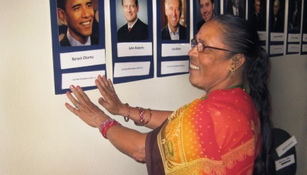
DAY 1: Refugees, asylees, and survivors of domestic violence

19 Our passage tells us that ”…it was evening on that day, the first day of the week, and the doors of the house where the disciples had met were locked for fear…” On the night of Jesus’ resurrection, fear kept those who loved and had followed Jesus huddled and hidden. It was still only hours since Mary Magdalene’s discovery of Jesus’ missing body and later encounter with her Teacher, and confusion and chaos swirled together with the hope that came from the new reality of the resurrection. What punishment or consequences might come upon Jesus’ followers by those who had crucified him just days before? Would they be blamed for Christ’s disappearance from the tomb? Who—even among Jesus’ closest disciples—fully yet believed the story that Mary had run back from the tomb to tell?

The pedestal of the Statue of Liberty proclaims, “Give me your tired, your poor, your huddled masses yearning to breathe free.” For well over a century, these words from poet Emma Lazarus have called out a welcome to the generations of immigrants that have shared our shores and shaped our heritage. They proclaim the intention, and offer the presumption, that those who have been huddling would find in the United States an opportunity to stop shaking, to build stability, to find both political security and stable relationships. They are words that understand well the trauma and fear that dominate the days of immigrants throughout their journeys to escape dangers, adjust to new realities, and re-define their communities in a new time and place.

What kinds of companionship might newcomers facing adjustment and anxieties find in knowing the disciples also faced fears amid their new reality after the resurrection?

Read the “Refugees, asylees, and survivors of domestic violence” issue brief and consider the challenges that Hana and millions like her face when coming to and living in this country. How can your faith lead you to establish personal relationships with, and fight for just policies for, refugees, asylees, and survivors of domestic violence?

Prayer: God who has guided your peoples through anxiety in all times, strengthen our ability to welcome those arriving at our shores. Increase our hospitality for the suffering, and make us sensitive to offer relationships that reduce the fears of those who endure daily transitions and uncertainties in their new lives as neighbors among us. Amen.

--Devotion offered by: Rev. Dr. Sharon Stanley-Rea, Director of Refugee & Immigration Ministries, Christian Church (Disciples of Christ)
sstanley@dhm.disciples.org. Member, Interfaith Immigration Coalition
Encountering IMMIGRATION ISSUES through devotions:

Living as Spirit Blessed Communities

John 20:19-22
DAY 2—vs. 19b
19When it was evening on that day, the first day of the week, and the doors of the house where the disciples had met were locked for fear of the Jews, Jesus came and stood among them and said, “Peace be with you.” 20After he said this, he showed them his hands and his side. Then the disciples rejoiced when they saw the Lord. 21Jesus said to them again, “Peace be with you. As the Father has sent me, so I send you.” 22When he had said this, he breathed on them and said to them, “Receive the Holy Spirit.”
DAY 2: Workers’ rights
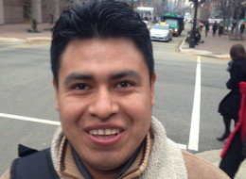

Although the disciples were hiding behind doors barred shut for fear of retaliation by those in political power, verse 19 tells us next that “Jesus came and stood among them.” In the days before his death, Jesus had promised his anxious followers: “I will not leave you desolate; I will come to you” (John 14:18.) Already that resurrection morning, Jesus had demonstrated a rock tomb could not contain him from living again near his followers. Now a door which the gospel writer seems intent to describe as “locked” lay between Jesus and the disciples he loved. Yet miraculously, Jesus nonetheless broke beyond the barrier to find them, despite their hiding—and intentionally came to be among them. Eight days later, he would again find his way in through locked doors to be with them in their fears. By doing so, Jesus demonstrated he was unafraid to be near and with them in their fear. He came into their shadowed existence to again be a part of their community. Yet, perhaps because he so understood their fears, he did not push them initially to take risks to show themselves to others beyond their level of comfort. Rather, his was a posture of comforting presence and accompaniment.

Daily, over 11 million immigrants in the U.S. live an existence shadowed in fears. “I am afraid for my mother to drive the car even to get groceries on the way home” said one recent 7 year old girl; fearful that her as yet undocumented mother might be detained or deported as she returns from work helping produce food, and then seeks to buy food for her own citizen children. Far too often, those who harvest the crops on our tables, or serve us in hotels, are held “locked in” their fears due to unjust work conditions and trafficking.

Can you think of ways Christ’s presence—through communities of faith—can, or has, intentionally sought to be present in comfort and intentional accompaniment with immigrant communities?

Read the “Workers’ rights” issue brief to learn more about how work practices too often keep immigrant families locked into poverty and fear. How might persons of faith act to be “barrier breakers” that open opportunities for immigrant families to move beyond oppressive work conditions and help grow more just worker conditions and wages?

Prayer: God who called us to treat new residents among us as citizens, help us remember the lives of persons like Antonio and Teresa who help meet the needs and contribute to the economy of our nation. At every meal we eat, may we remember the ones who have helped to grow and harvest our food. May our awareness be turned to actions for worker justice. Amen.

--Devotion offered by: Rev. Dr. Sharon Stanley-Rea, Director of Refugee & Immigration Ministries, Christian Church (Disciples of Christ)
sstanley@dhm.disciples.org. Member, Interfaith Immigration Coalition

Encountering IMMIGRATION ISSUES through devotions:

Living as Spirit Blessed Communities

DAY 3: The root causes of migration
John 20:19-22
DAY 3—vs. 19end-20
19When it was evening on that day, the first day of the week, and the doors of the house where the disciples had met were locked for fear of the Jews, Jesus came and stood among them and said, “Peace be with you.” 20After he said this, he showed them his hands and his side. Then the disciples rejoiced when they saw the Lord. 21Jesus said to them again, “Peace be with you. As the Father has sent me, so I send you.” 22When he had said this, he breathed on them and said to them, “Receive the Holy Spirit.”
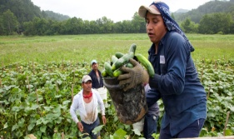
Was presence and accompaniment all that Christ offered his followers? After entering through the keyhole and into the place where the disciples had gathered in shivering and hiding to find security, Christ very quickly offered them a gift even beyond his presence. He stood among them with a particular message: “Peace be with you.”

Jesus’ committed and barrier breaking presence despite a locked door, his accompaniment, and the gift of peace are all offered within a single sentence! In both verse 19 and in verse 21 of our passage, Jesus reiterates his intention to not only be present, but also to define what his presence means and can bring to the disciples’ community. In chapter 14:27 of John’s gospel, Jesus had first offered peace as a “parting gift” before his death—saying “Peace I leave with you; my peace I give to you; not as the world gives do I give it to you.” Rather, Jesus’ peace offered a way to “let not your hearts be troubled, neither let them be afraid” (again, 14:27) in the midst of any earthly challenge.

Now after his resurrection, Jesus’ new presence has come to offer an even deeper fulfillment of the earthly peace previously granted. Jesus’ peace is not any superficial calm that consists of a mere absence of fighting or the repression or denial of conflict. It was a peace defined incarnationally; as Jesus turned to his body immediately after his offering of peace to show them his hands and his side. By so doing, he demonstrated peace as that which conquered his own pain and suffering. His living again among them showed—very concretely—his victory over the injustices faced in his own life. And so, the peace Christ offered contains the challenge to allow his peace to continue to give courage that dissipates fear of the world’s ongoing persecution and builds trust in God’s ongoing victory over injustice.

Those who begin a journey of migration and ultimately enter the U.S. do so most often because of root causes that underlie their need to leave their homes of origin. These root causes especially include realities of extreme poverty, political instability and violence, and other physical and environmental threats. Theirs are home environments where peace can be difficult to find, and complex international trade policies—often from the U.S. side—further exacerbate the injustices experienced in their homelands.

What might Christ’s offer of peace, incarnated in his life and made victorious through his resurrection, offer to individuals and families of immigrants facing the constant pushes of root causes that lead to their migration?

Read more about what causes immigrants to come to the U.S. in the issue brief “The root causes of migration.” What have you learned about how our own government’s policies intersect with the “push factors to move” that affect migration patterns and numbers? What roles do you hope your faith community might play in strengthening just trade policies and offering real peace for the lives of our global neighbors?

Prayer: Creator of the whole world and its peoples, we thank you, God, for the uniquenesses of each country and populations. Make us faithful stewards of our resources, generous sharers of our resources, and good neighbors to those nations which surround us near and far. Grow within us a deeper understanding of our connectedness and our potential to help your peace influence those factors which cause families to make painful choices to move from their homelands. Amen.
--Devotion offered by: Rev. Dr. Sharon Stanley-Rea, Director of Refugee & Immigration Ministries, Christian Church (Disciples of Christ)
sstanley@dhm.disciples.org. Member, Interfaith Immigration Coalition

Encountering IMMIGRATION ISSUES through devotions:

Living as Spirit Blessed Communities
John 20:19-22
DAY 4—vs. 20b
19When it was evening on that day, the first day of the week, and the doors of the house where the disciples had met were locked for fear of the Jews, Jesus came and stood among them and said, “Peace be with you.” 20After he said this, he showed them his hands and his side. Then the disciples rejoiced when they saw the Lord. 21Jesus said to them again, “Peace be with you. As the Father has sent me, so I send you.” 22When he had said this, he breathed on them and said to them, “Receive the Holy Spirit.”
DAY 4: A path to citizenship

Although no “media moguls” were in the room to Tweet or Facebook the reactions of the disciples, Christ’s physical documentation of his survival of suffering by showing his hands and his side produced a clear and seemingly immediate response. At the close of verse 20, we are told, “Then the disciples rejoiced when they saw the Lord.” It was an age long before “social media.” Yet, brand new feelings began instantly to “trend” within their society as the evidence of Christ’s overcoming of pain and death led to celebrations that dominated even the fears that had held them behind the locked door! Their fear of consequences upon their faith community finally began to relax, and instead their hearts began to feel joy and—finally—freedom!
The kind of documentation being asked for from entering immigrants today is much more than the requirements made upon many of our own ancestors. All immigrants struggled for acceptance, but yet papers weren’t asked to be presented. Our nation’s immigration laws have become increasingly complex; leading today to the separation between those termed to be “documented” versus “undocumented.” Jesus in verse 20 discloses a new form of “documentation” based upon his own suffering. By showing his hands and side, he “documents” God’s intention to bring the hope of freedom from persecution to the world.
How does a lack of citizenship opportunities continue to hold immigrants locked in fear and often ethnic persecution? How might we represent Christ’s hope for freedom beyond suffering by supporting our immigrant neighbors in their quest for citizenship status?
Read the issue brief “A path to citizenship” to learn more about the importance of citizenship status. What types of challenges and roadblocks are often encountered by immigrants to work, learn, and contribute to society throughout the long years of their journeys toward citizenship? What might be one or more specific actions you or your faith community can take to cultivate hospitality that communicates the freedom of Christ by supporting DREAMers or others seeking citizenship status in your community?
Prayer: God, help us live as Christ lived to reduce the suffering of those in our communities who have felt bound and afraid. Give us courage to offer the freedom we feel through you by offering those who have come to reside among us. And keep us open to the reality that, as we offer hospitality, we may be influenced beyond our imagining by the strength and courage of our immigrant neighbors. Amen.

--Devotion offered by: Rev. Dr. Sharon Stanley-Rea, Director of Refugee & Immigration Ministries, Christian Church (Disciples of Christ)
sstanley@dhm.disciples.org. Member, Interfaith Immigration Coalition

Encountering IMMIGRATION ISSUES through devotions:

Living as Spirit Blessed Communities

DAY 5: U.S.-Mexico border policies
John 20:19-22
DAY 5—vs. 21
19When it was evening on that day, the first day of the week, and the doors of the house where the disciples had met were locked for fear of the Jews, Jesus came and stood among them and said, “Peace be with you.” 20After he said this, he showed them his hands and his side. Then the disciples rejoiced when they saw the Lord. 21Jesus said to them again, “Peace be with you. As the Father has sent me, so I send you.” 22When he had said this, he breathed on them and said to them, “Receive the Holy Spirit.”

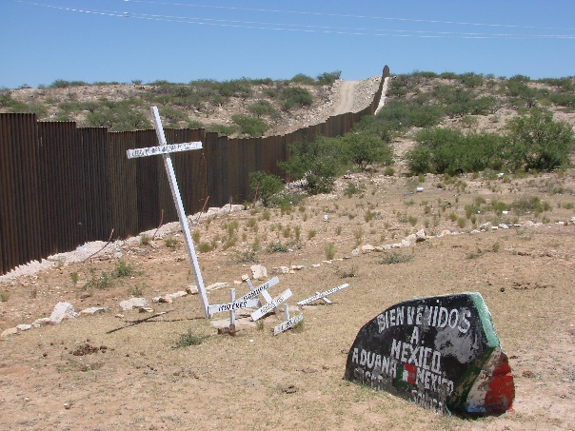
In verse 21, Jesus encourages his followers again by reminding them of the peace his life and overcoming of death offers to them. But in the passage, it becomes now—and only now—that Jesus asks his followers to dare to put their fears into “lock down mode” instead of them staying locked in behind a closed door! Jesus seems to be very sensitive to how hard it must be for them to think about claiming the courage and freedom he has offered in a way that changes their behavior. And so, Jesus continues his teaching after he reiterates his offering of peace by saying in verse 21, “As the Father has sent me, so I send you.”

The same Jesus who came to them out of the grave and through a locked door is also one who desires to send them away from their fears which threaten to entomb and stifle their freedom. Jesus encourages them to leave their place and behavior of hiding, to move beyond themselves, and to step forward as ones intended to convey the peace they have been granted to others outside the locked door. In this way, Jesus asks his followers to live in the pattern of his own life; Jesus was sent by God to them, and we are sent out by Jesus. The gift of peace (offered twice within just three verses!) is the first gift offered to give us the courage to go forward. Jesus is one who, in both coming to us (through a locked door) and in sending us out, breaks boundaries and moves beyond borders!

Mexico is our nearest neighbor in the U.S., with a long previous history of porous and productive relationships across the borders. “We used to cross the border all the time in earlier years to shop, visit, and get medical care” stated one Hispanic pastor’s wife in Texas, who lives just above Matamoros, Mexico. “But in recent years, the crossing is so much more dangerous, and more expensive due to violence and economics in Mexico.” With a nearly 2,000 mile border that spans six Mexican states and four U.S. states, it encompasses major urban areas and vast and inhospitable desert lands. Desert, financial, and safety challenges have resulted in over 4,000 persons dying while attempting to cross the border since 1998.

Are there any messages about borders and boundaries you hear communicated through passages like verse 21 above? How does your faith inform your preferences about U.S.-Mexico border policies and treatment of those detained during or after crossing?

Read the “U.S.-Mexico border policies” issue brief to encounter the human challenges, and see the human faces, that are affected by U.S. border policies with our neighbor Mexico. Consider the story of 16 year old Humberto, and share other stories of families you may know who have been affected by our country’s border policies. How much do you think our nation should spend on enforcement? How might you or your faith group consider voicing your desire for what you believe are the most humane deportation practices?

Prayer: God who calls us to “love our neighbor as ourselves,” keep us praying often for our near neighbors in Mexico, and for those whose families are separated on both sides of the border. For those who may be crossing that border today, we pray for safety. Be ever near to them and to us, dear God, that we may hear your voice speaking to us with compassion and vision as we engage in efforts to be faithful followers of you, and welcoming friends among our neighbors. Amen.

--Devotion offered by: Rev. Dr. Sharon Stanley-Rea, Director of Refugee & Immigration Ministries, Christian Church (Disciples of Christ)
sstanley@dhm.disciples.org. Member, Interfaith Immigration Coalition
Encountering IMMIGRATION ISSUES through devotions:

Living as Spirit Blessed Communities

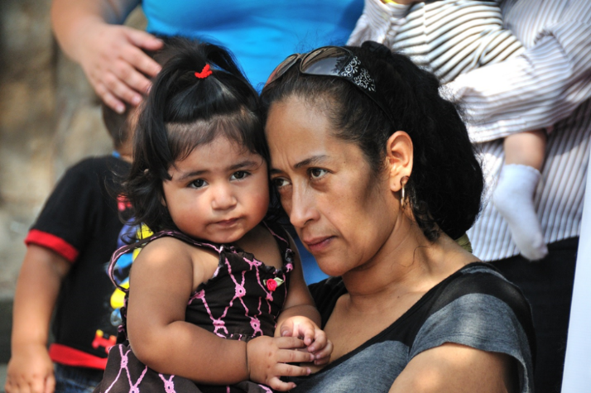
John 20:19-22
DAY 6—vs. 22
19When it was evening on that day, the first day of the week, and the doors of the house where the disciples had met were locked for fear of the Jews, Jesus came and stood among them and said, “Peace be with you.” 20After he said this, he showed them his hands and his side. Then the disciples rejoiced when they saw the Lord. 21Jesus said to them again, “Peace be with you. As the Father has sent me, so I send you.” 22When he had said this, he breathed on them and said to them, “Receive the Holy Spirit.”
DAY 6: Immigration enforcement

The morning of the day that precedes this passage had started with an experience that left Mary breathless. As she’d gone to the tomb where Jesus had been lain (John 20:1), it was empty! Running to tell the others, her physical breathlessness became matched by a her soul’s breathlessness from anxiety. Struggling to regain air to tell her remarkable story to others, Peter and the other disciple responded to her story not with words, but like relay racers—as they ran again back to the tomb to confirm the news.

As the day wore on, fear continued to take away more of the disciples’ breath. Then at nightfall, they were again made breathless by the shock that Christ’s miraculous entry through their locked door must have caused! With all the breathlessness of the day, how comforting it must have been to experience what Jesus did next! As a follow up on his sending of them in verse 21, he offered a simple but powerful gesture as he gospel says he “breathed on them” (verse 22.) Before they took any step, Jesus gave them “out the door breath.” It was a gift better than a warm coat, more protective than an umbrella, more comforting than the best GPS. Jesus’ breath offered them life for their journey.

So many of our policy discussions, and our national resources, are invested in strengthening our borders…making sure walls that divide us become deeper, longer, more fortified. Indeed, U.S. taxpayers spent over $18 billion on immigration enforcement in 2012 alone. This amount was more than was spent on all other federal law enforcement agencies combined.

Read the “Immigration enforcement” issue brief. Review the statistics of resources invested and families impacted by border practices, and discuss the following: What kinds of border security best help communicate your core faith values? How do you hope that enforcement practices treat the individuals and families like Maria and Nichole? Have you heard other stories in your community of persons detained, and what treatment do you hope they would experience as our country struggles to reform our policies?

Prayer: Boundary breaking God, make us forever grateful for the security we find in you. Guide us to build our knowledge of our nation’s actions at our borders. Move through our hearts with your wisdom to send us forward with messages to speak with our legislators to communicate our visions of humane enforcement. And empower our actions to build relationships with our immigrant neighbors that help them move beyond fear and find full freedom of opportunities for a better life as your children. Amen.

--Devotion offered by: Rev. Dr. Sharon Stanley-Rea, Director of Refugee & Immigration Ministries, Christian Church (Disciples of Christ)
sstanley@dhm.disciples.org. Member, Interfaith Immigration Coalition

Encountering IMMIGRATION ISSUES through devotions:

Living as Spirit Blessed Communities
John 20:19-22
DAY 7—vs. 22b
19When it was evening on that day, the first day of the week, and the doors of the house where the disciples had met were locked for fear of the Jews, Jesus came and stood among them and said, “Peace be with you.” 20After he said this, he showed them his hands and his side. Then the disciples rejoiced when they saw the Lord. 21Jesus said to them again, “Peace be with you. As the Father has sent me, so I send you.” 22When he had said this, he breathed on them and said to them, “Receive the Holy Spirit.”
DAY 7: Family unity

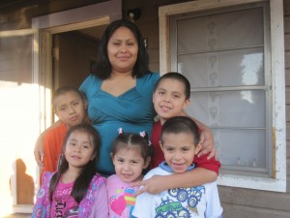
After giving the gift of peace (and reminding them of it a second time!), after calling them to following his pattern of being sent, and after boosting their readiness by sharing life through his breath, Jesus finished his gift giving by clarifying the source of the life and hope he offered them. “Receive the Holy Spirit” said Jesus after he breathed on them. And so, by blowing in the breath of the Holy Spirit, Jesus “commissioned them.”

Jesus offered a final preparation for their sending in a way that evoked how Yahweh had “breathed into the nostrils the breath of life” in Genesis 2:7 to form the first human being during creation. Jesus, who in John 19:30 had “given up his spirit” on the cross now passed the Spirit forward to his disciples. By doing so, he gave his community the fullness of what he’d promised at the Last Supper to give to them in order that they might carry out their sacred mission to “wash one another’s feet” (John 13:14) and “love one another; even as I have loved you” (13:34.) In a breath that blew like the wind, Jesus blew into their lives a share of his own relationship with God. It was to be a wind they experienced again in the rush of the Holy Spirit that was to come soon to give witness among all languages on the day of Pentecost.

Immigrant families understand quite well the need to be sent. Despite love of their own homelands, families are often pushed by the violence and economic poverty of their homes to take great risks for a better and safer life. Some family members are often sent to benefit the others who remain; sending a high percentage of limited wages through farm or other work back to their families. But far too often, families sent to the US are separated either in route or through detention and deportation after arrival. The verses of the passage we have studied all seem oriented to build unity and courage of Jesus’ community, that they may offer hope and life to others beyond fears.

How do we believe the breath of the Holy Spirit might lead us to work for the safety and unity of families separated by perilous journeys and unjust deportation practices?

God grows and blesses followers through descendants and over generations in both the Hebrew Bible and the Christian texts. Read the “Family unity” issue brief to hear the story of Leydi’s family and to understand more about the intersection between family struggles and U.S. immigration processes. How do you think the emphasis of family relationships in scriptures leads you as a person of faith to support the unity of immigrant families? How might your faith lead you to be involved in helping to stop the trafficking of especially mothers and children who are immigrants? What other stories have you heard in your church, or in the news, of children, parents, and spouses separated from one another due to current deportation practices, and in what ways do you feel ready to act to breathe hope into immigrants’ lives and new life into our nation’s immigration policies?

Prayer: God who so valued us as individuals that you stamped us with Your image, we give you thanks for your creative touch. We praise you, too, for then placing each of us within families—of our birth, and chosen communities—which continue to nurture and guide us. For every family member pulled apart through migration from those they love, we pray Your presence may be near them. Offer healing for children who miss their parents and courage for parents making unbelievable sacrifices to support their families. And remind us, God, of how you call us to be unified as One, in a family of faith, bound together by your Pentecost Spirit, to follow you and to share your breath of life with our hurting and fragmented world. Amen.

--Devotion offered by: Rev. Dr. Sharon Stanley-Rea, Director of Refugee & Immigration Ministries, Christian Church (Disciples of Christ)
sstanley@dhm.disciples.org. Member, Interfaith Immigration Coalition

