So be strong and courageous! Do not be afraid and do not panic before them. For the Lord your God will personally go ahead of you. He will neither fail you nor abandon you. (Deuteronomy 31:6, NLT)
On this Veterans Day, 2019, we honor our courageous and strong immigrant warriors. They trusted in the Lord and the United States Armed Forces as they served and sacrificed for our country. We hold in prayer those DACA youth who joined the military with reasonable expectations for citizenship but are being discharged instead. We stand in solidarity with the immigrant veterans who have served, been wounded and honorably discharged only to be deported from the home they risked their lives to protect. We pray for a renewal of integrity in our country’s promises and reunification of veteran families. Their faith in God was well placed but our country is failing our vets, and we must not abandon them.
He stands ready.
John Candido is a husband, father, dreamer, DACA recipient, human. John’s dream had always been to enlist in the military. He had hoped to, in his words, finally make up for being in the country illegally by joining and serving in the military. He was the given the opportunity to do so through a program called MAVNI (Military Accessions Vital to National Interest) which, from 2014-2016, gave DACA recipients the ability to earn a path to citizenship by enlisting in the military and completing basic training.
Excitedly, John signed up to join MANVI as soon as he was eligible to do so. However, by 2016, the military had identified security threats within the program and stopped accepting new recruits. At the same time, they began subjecting those already enlisted to increased vetting. John now waits for the military to re start the program and allow those already accepted to complete the process.
Approximately 300 other DACA recipients who had signed contracts to serve and are still waiting to ship off to basic training. Just like that, a dream snatched away, a contract broken, a life thrown abandoned; he describes it as “…you’re on an island by yourself waiting, while the rest of the world is just going on.” Source:https://www.pbs.org/newshour/show/daca-recipients-who-dream-of-military-service-are-stuck-in-limbo
John trusted the promises of the military but they have failed him. And, for John, justice delayed is justice denied.
He served our country well…
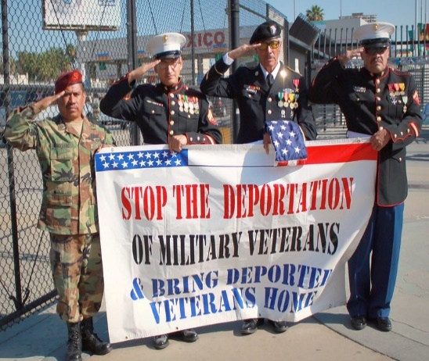
Unlike John, Miguel was a legal permanent resident who was permitted to serve his country.

Miguel, a Mexican native, grew up in Chicago. Miguel and his parents legally emigrated to Chicago in 1989. After 9/11, he soon joined the Army and served two tours in Afghanistan. Miguel returned home with post-traumatic stress disorder and a severe brain trauma he incurred when his vehicle was hit by a grenade. Once home, he endured protracted delays for a medical appointment. While he waited for treatment, Miguel hooked up with an old friend and began to self-medicate with illicit drugs.
Figure 1At the San Ysidro-Tijuana Border Port of Entry by aprils_photos https://www.flickr.com/photos/aprilspoliticalphotos/69148247/in/photostream/

That search for peace led to an arrest and subsequent conviction that resulted in prison time. Although he finally received appropriate treatment for his combat related illness in prison, his conviction activated deportation proceedings. Upon release from prison, Miguel was detained and deported to Matamoros, Mexico in 2018.
Immigration and Customs Enforcement (ICE) policies require it to take precautions prior to deporting a veteran, including consideration of their service record. In June of 2018, The Governmental Accountably Office found that, in 70% of cases reviewed, ICE did not follow these policies from 2013-2018. Furthermore,
“ICE does not maintain complete electronic data on these veterans. As a result, ICE does not know how many veterans have been placed in removal proceedings or removed.” See https://www.gao.gov/products/GAO-19-416 The GAO also noted that naturalizations of non-citizen veterans were down 72% since 2018. This is partly due to the closing of on-base programs that allow for and assist in naturalization applications. Id.
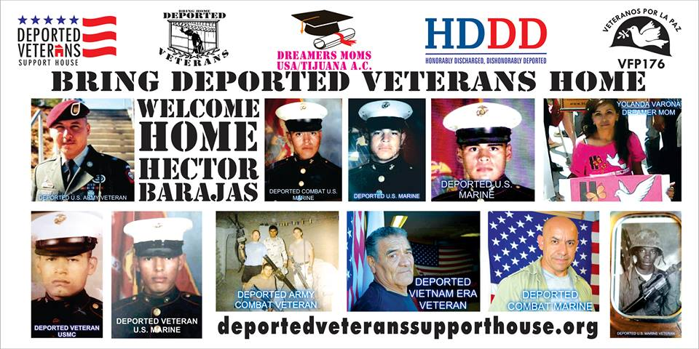
Remarkably, in August of 2019, Governor J.B. Pritzker pardoned Miguel, “to allow a U.S. veteran the opportunity to be treated fairly by the country he served.” After reconsideration of his citizenship case, he was sworn in as a U.S. citizen in October, 2019. Justice was restored for this veteran.
Miguel is among an estimated 250 veterans who have been targeted for deportation in recent years. Many U.S. veterans remain in foreign countries, separated from families and lacking medical care for combat related injuries. They have been deported to countries that they no longer know and some don’t even speak the native language. Discarded by the very country for which they risked their lives, some veterans have united forces to help each other in Juarez or Tijuana, Mexico. Justice, and our gratitude, elude them.
Figure 2Facebook page of Tijuana Bunker House for deported veterans https://www.facebook.com/DeportedVeteransSupportHousePage/photos/p.1895858783793602/189585783793602/?types=1&theater

Call to Action:
- Call your Congressional representatives and tell them you want to see the promises of the MANVI Program completed for all DACA recruits. Remember the representatives’ responses in 2020 when you vote.
- Research the Deported Veteran Support Houses, aka the “Juarez and Tijuana bunkers” of Mexico, to find ways to assist our displaced and abandoned veterans .
- Write a letter to the editor of your local papers to increase awareness of the justice denied to DACA military aspirants and deported vets.
- Call your congressional representatives and insist they demand observance to ICE safeguards for veterans prior to deportation of a veteran.
Veteran’s Day Prayer
Loving God,
Let justice roll for all of our veterans who have selflessly served the United States of America. May we now stand up for them, in opposition to perverse friendly fires that are created by cruel politics and ingratitude. We pray that every veteran of our nation’s armed forces experiences the profound gratitude of all the brothers and sisters they so bravely served. Holy Protector, let no racist fear, political machinations or inexplicable lack of gratitude cause a soldier to feel discarded, marginalized or betrayed.
Make us a grateful nation who honors a veteran’s sacrifice and service with appropriate respect for their gift to us. Bring our soldiers home to the USA, and dear Lord, let us leave never leave a soldier behind or displaced. May we welcome them home to the USA as You welcome those who came home to You. Amen.

