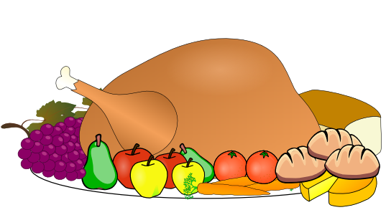
Who’s Behind Our Feast?

Thinking of Farm Workers on Thanksgiving

- There are an estimated 3 million farm workers in the United States.

- Over 50% of these farm workers lack official documentation, which puts them at risk of abuse and deportation.

- 85% of fruits and vegetables produced in the US are picked by farm workers by hand.

- The average farm worker makes only $11,000/yr, but the fruit & vegetable industry generates an estimated $28 billion/yr.

Farm workers make our meals possible, and without them food-filled holidays like Thanksgiving wouldn’t be the same.

But at what cost to them?

Farm workers are one of the most highly at risk social groups in our country. They make low wages, work long hours in dangerous conditions, lack access to unions and proper healthcare, and many are undocumented.

And yet, we depend on their risky work all of the time.

You’re invited to take a closer look at who is behind the platter on Thanksgiving—
and at every meal!

“Look! The wages you failed to pay the workers who mowed your fields are crying out against you. The cries of the harvesters have reached the ears of the Lord Almighty.”—James 5:4

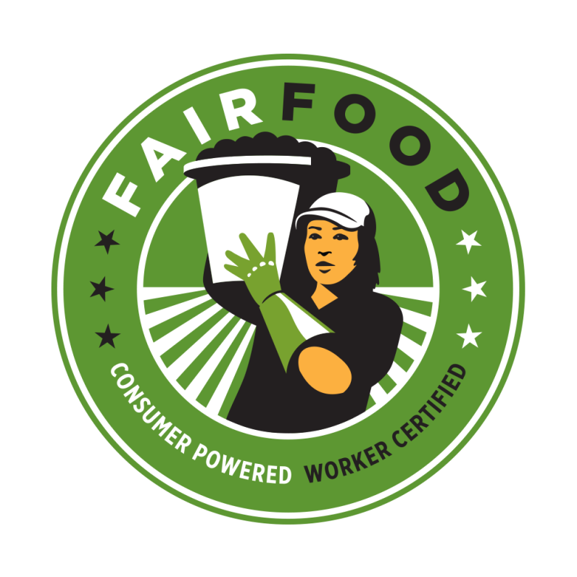
How Can We Support Justice for Farm Workers?
Learn About Who Grows Our Nation’s Food!

- Plan a “Harvest of Justice” event in your congregation or community to teach about farm worker conditions, learn about the National Farm Worker Ministry, and find out how you can support various faith campaigns for farm worker justice!
-- http://nfwm.org/2009/06/planning-a-harvest-of-justice/

- Support initiatives like the Fair Food Program that engage farm workers and corporations to support equitable pay for their work and allows consumers to support food that was fairly paid for
—http://www.fairfoodprogram.org/.

- Learn ways the Coalition of Immokalee Workers is helping to reduce sexual violence among agricultural workers --http://www.ciw-online.org/blog/2017/09/harvest-without-violence/

- Show “Food Chains”—A documentary that exposes the abuse of farm workers within the United States and the complicity of the multibillion dollar supermarket and fast food industries
—http://www.foodchainsfilm.com

- Read this article about living conditions and work experiences of farmworker children and their family, including 27 year old DACA recipient son Jose Delgado, who entered the US as a baby--
https://www.cbsnews.com/news/undocumented-farmworker-families-immigration-reform/

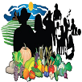

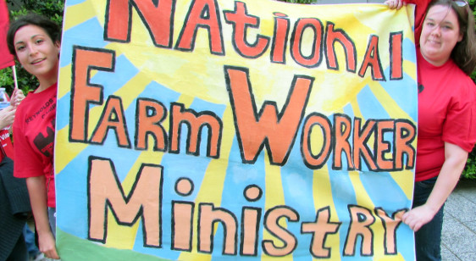

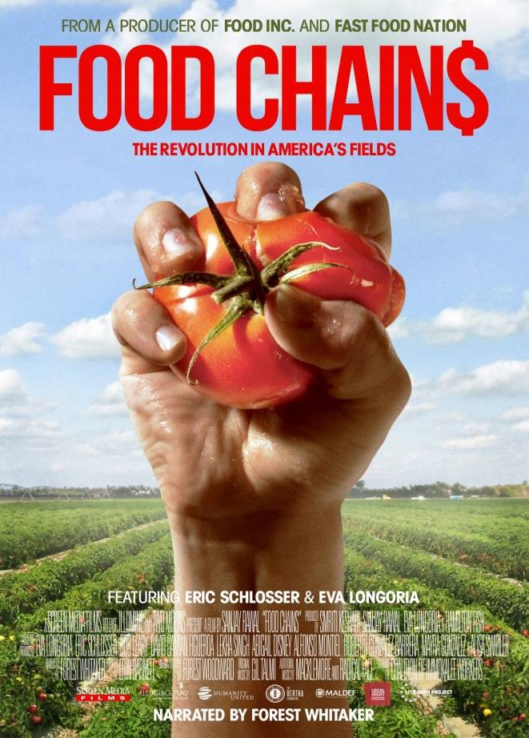

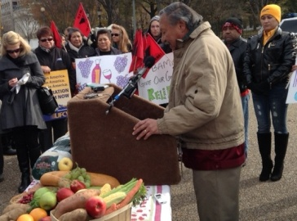
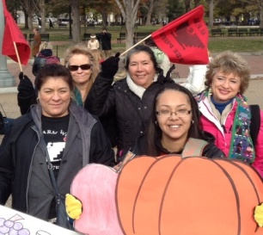
Who Grows the Food for Our Feasts? Hear the stories of farmworkers below, who held a “farmworker Thanksgiving” recently outside the White House, and shared how they provide foods for Thanksgiving feasts around the country!
Enjoy learning from their stories and photos below as you prepare for your own family’s Thanksgiving celebration!

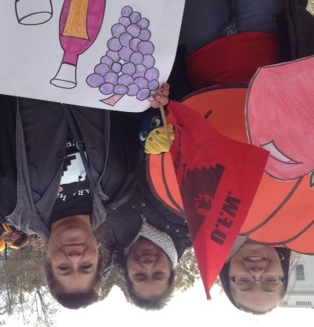
Pumpkin grower Maria Martha Acevedo Cardenas from Sunnyside, WA recalls the sacrifices farm workers make behind every Thanksgiving meal, saying, “I'm not asking for pity, but I am asking for what's fair. Farm workers need immigration reform. Others are able to eat the best produce, while we are unable to afford the same fruits and vegetables we picked. One day, I would like to be able to buy my own Thanksgiving turkey. Martha also works at Chateau Ste. Michelle Winery. She came to the U.S. in 1985 from Mexico in search of a better life for herself and her small son. She has also worked in apples, tomatoes, cherries, asparagus, green beans, onions, grapes and pears. On an average workday, Martha wakes up at 3 or 4 a.m. to be at work by 6 or 7 a.m." Her U.S. citizen daughter, Eustalia (Toy) A. Acevedo, who picks apples in Seattle, WA, has also worked harvesting many other crops with her mother. With working with apples last year, Toy climbed up and down a ladder 8 or 9 hours a day, carrying a bag that she filled with at least 40 pounds of apples before dumping them into a bin. She filled that bag at least 7 times a day. She says, “When the average American eats that apple pie or a dish with apples on Thanksgiving, they need to realize without farm workers picking their fruits or vegetables there wouldn't be a Thanksgiving meal.”

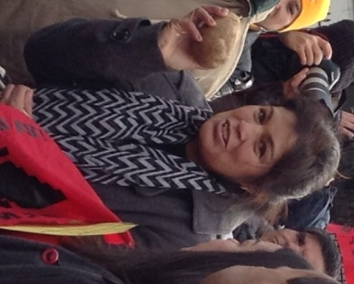
Maria Arteaga, harvests potatoes in Parma, ID. The planting process for potatoes is a long one because she has to be sure only the best “eyes of potatoes” are used, and she has to cut the potatoes carefully yet swiftly with a knife without cutting herself. Maria has been in the U.S. for 23 years. Several years ago she and her husband were stopped and subsequently deported for “looking suspicious” while on a road trip to Los Angeles. At the time her small children, including her daughter Areli, then 5, had stayed home with a relative while they were away. "Once I was deported, all I could think about was my children. I had to get back to them. I did what any mother would have done. I made the sacrifice and returned to the U.S. illegally." Her daughter, Areli, often helps with corn harvesting when she comes home from college where she studies as a double major in political science and business. Areli says: “I want people, who don't believe we need immigration reform to think about something before they bite into their corn on the cob: some people, unlike them, can't be sitting at the table enjoying a Thanksgiving meal with their family because they can't travel out of the country to see them or because their family has been deported."

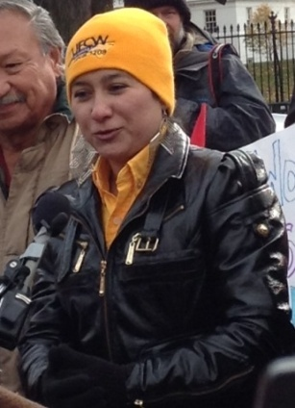
San Juanita Marquez works at a poultry processing plant worker in Lumber Bridge, NC. She explains the perils of life as an undocumented worker: “If immigration (U.S. Immigration & Customs Enforcement) comes to the plant or my house, I could be separated from my children. My youngest children are American citizens, and because I have no family here, they would be left alone and be sent to foster care if I was deported. It would be too dangerous to take them back to Guerrero where children and the elderly are gunned down in gang violence. I ask our President to stop the deportations. Let us work and let us keep our children safe.”

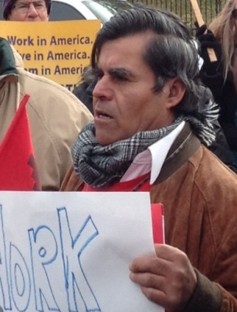
Inocencio Bernal Pedroza picks celery, like that often used in stuffing at Thanksgiving, in Madera, CA. Inocencio is proud that the celery, grapes, cauliflower, and peaches he has picked are used to make delicious dishes at Thanksgiving. He reminds, “Farm workers contribute to the U.S. economy, but many of them are undocumented and are not treated equally or acknowledged for their work. They provide food for American families. Americans should try to have to have their Thanksgiving meal without undocumented farm workers toiling in the fields. There would be no dinner! There's produce in the supermarkets because farm working hands put it there.” Inocencio has worked in the Central Valley since 1991. He knows that more work needs to be done to improve the conditions for farm workers. He says, “I, and other farm workers, are willing to work, willing to help, willing to contribute to the economy of this country. We have hope and faith that our company will implement a contract to better protect workers in our company." His employer has refused to sign a mediated contract for many years, and will require many to work on Thanksgiving Day without holiday pay.
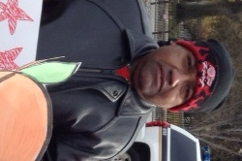
Alberto Bermejo is 44, and picks peaches in Sanger, CA. This year alone, Alberto harvested peaches for 6 months. He said peaches are most often used to make peach pie or cobbler on Thanksgiving. On an average workday, Alberto climbs up and down a ladder to pick peaches for at least 8 hours. He picks peaches from at least 80 trees a day. While many of us are still sleeping, Alberto begins his workday at 5:30 a.m. Alberto came to the U.S. in 1986. He is grateful that his hard work will feed Americans this Thanksgiving. But, he says, “If we're not in the fields picking the peaches, then people won't be served on Thanksgiving. A little appreciation for what we do would go a long way." Other crops Alberto has worked in include nectarines, olives, and oranges.

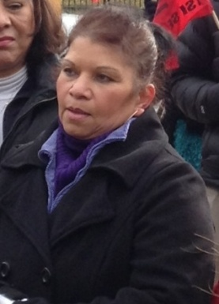
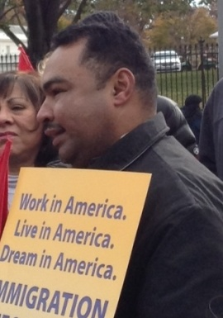
Juan and Maria Pacheco achieved American citizenship after years of working at a turkey processing plant in Mifflintown, PA. Juan says, “Families all across the country are going to be eating our turkeys on Thanksgiving, but they don’t know the stories behind their Thanksgiving dinner. My wife and I worked in the Empire Kosher turkey plant for fifteen years before we finally earned American citizenship. We have worked hard to earn our American Dream. I want to stay here all of my life, working hard.”
Stories provided by the United Farm Workers (www.ufw.org) and the United Food and Commercial Workers (www.ufcw.org). Photos by Rev. Sharon Stanley-Rea, Director, Christian Church (Disciples of Christ) Refugee & Immigration Ministries; sstanley@dhm.disciples.org.
For Additional Holy Days & Holidays Resources, go to: www.interfaithimmigration.org

